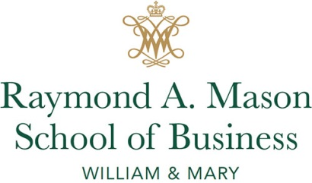
William & Mary Business School Foundation
Letter of Commitment

In support of William & Mary and my 20th Reunion, I commit the following to the William & Mary Business School Foundation for the MBA Class of 1999 Scholarship Endowment (4573).

Name:
Address:
Email:
Phone:

Paid On or Before Amount
June 15, 2019 $___________
June 15, 2020 $___________
June 15, 2021 $___________
June 15, 2022 $___________
June 15, 2023 $___________

Total Commitment $___________

Gifts for graduate scholarships are eligible to be matched by the McGlothlin Scholars program up to approximately $550,000 annually.

_______________________________________________ ______________________________
Signature Date

Payments may be made by:
- Check – payable to the William and Mary Business School Foundation

- Credit Card – Visa/MasterCard/American Express/Discover on your reunion page at: www.WMAlumniWeekend.com

- Securities – Please contact Jordan Hunt, Director of Development for MBA programs, at jordan.hunt@mason.wm.edu or (757) 221-2796.

Office of Gift Accounting | William & Mary | P.O. Box 1693 | Williamsburg, VA 23187

